Data Pipelines with TensorFlow

Data powers al of our ML models and TF Data services makes managing this data much easier.

Week 1

Types of data that you would normally come across when doing ML:

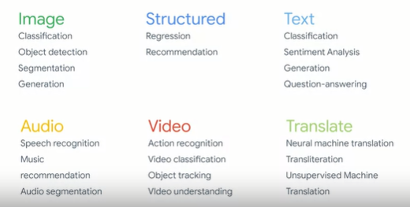

The bottom line for the best possible experience in training models we all need acquiring, formatting, and pipelining data into TF to be as simple as possible. With TF datasets you can do away with all of these problems by having a platform containing datasets that are accessible with a consistent API.

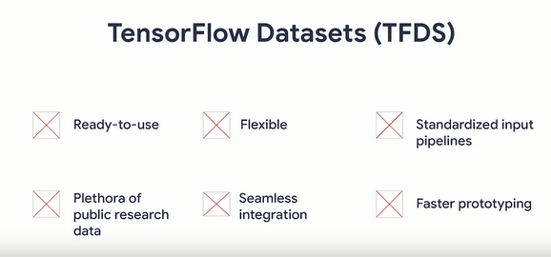

TF datasets is a collection of datasets of various types that has been opened up for everything from simple learning to cutting edge research, or with a consistent API. TFDS was built with the intention of easily integrating your dataset seamlessly with TF’s training pipeline. It’s very flexible to switch between different datasets with minimal code changes and to handle diverse data structures and use cases. Here are some of the well-known datasets available in TFDS

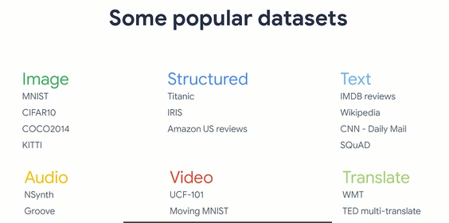

Data pipelines work on the principle of ETL

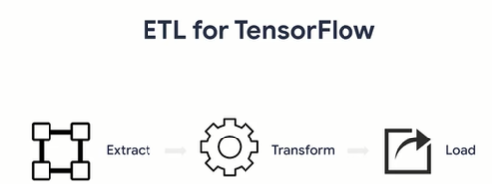

Separating these tasks allows you to make systems that are less brittle to changes in the underlying data. With this principle, tfds and tf.data just extract data from simpler sources, like in memory arrays. But also large data sets which are composed of multiple shards distributed in cloud storage systems. It can then transform the data, a process of extracting features performing augmentation on you data. And also converting data to tensors when necessary to get it ready for training. By the time you have your transformed data, you can then go ahead and load it into the appropriate device. Such as a GPU or TPU with a set of tools in TF. How you load the data can have a significant impact on the performance of your training pipelines.

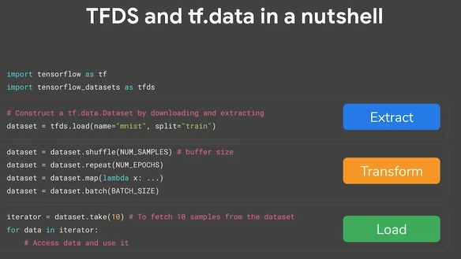

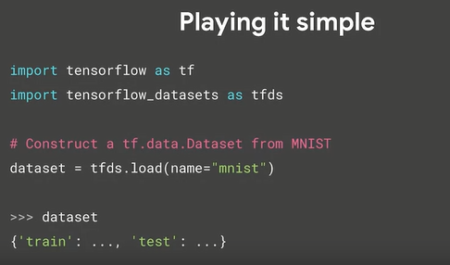

Now what if we only want load the train split of the dataset: use the split parameter in tfds.load API

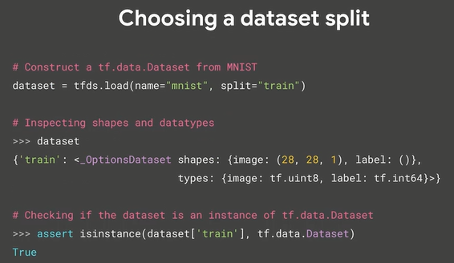

To see al of the available datasets in TFDS you call the list.builders method

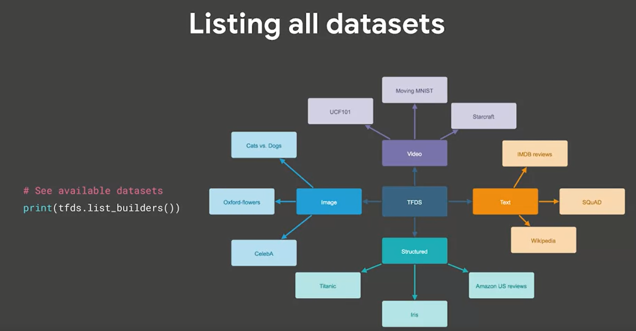

To inspect the metadata of TFDS we can use the datasetinfo class

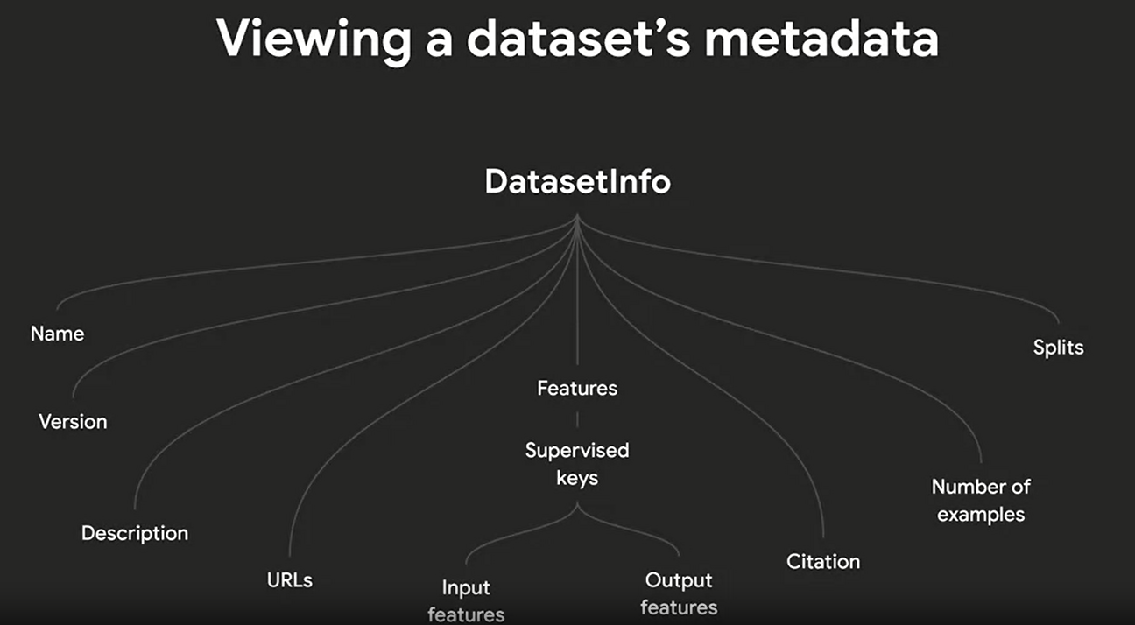

To view a dataset’s information pass with_info equals true into the tfds.load API.

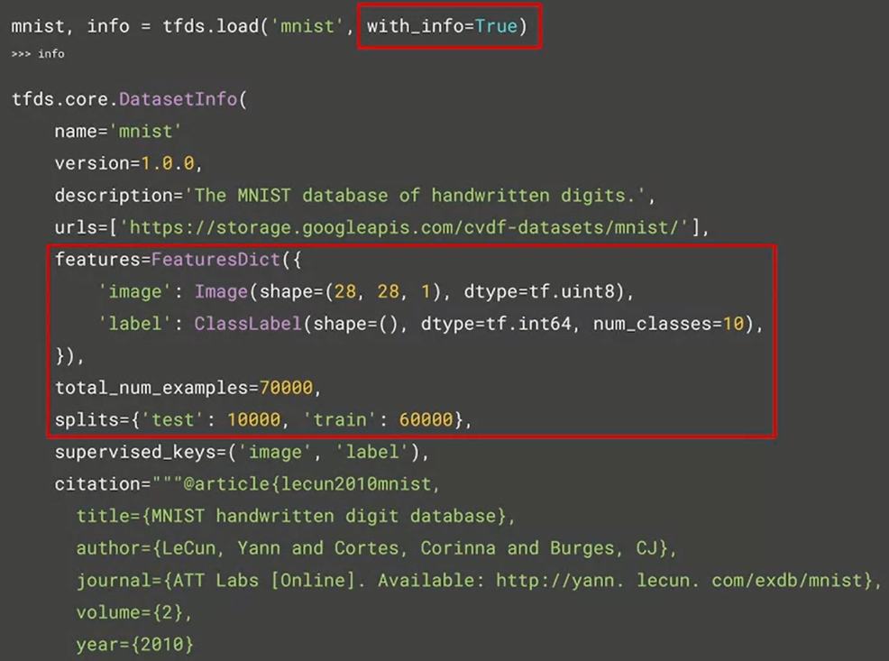

Example of extracting data from the datasets info object returned by tfds.load

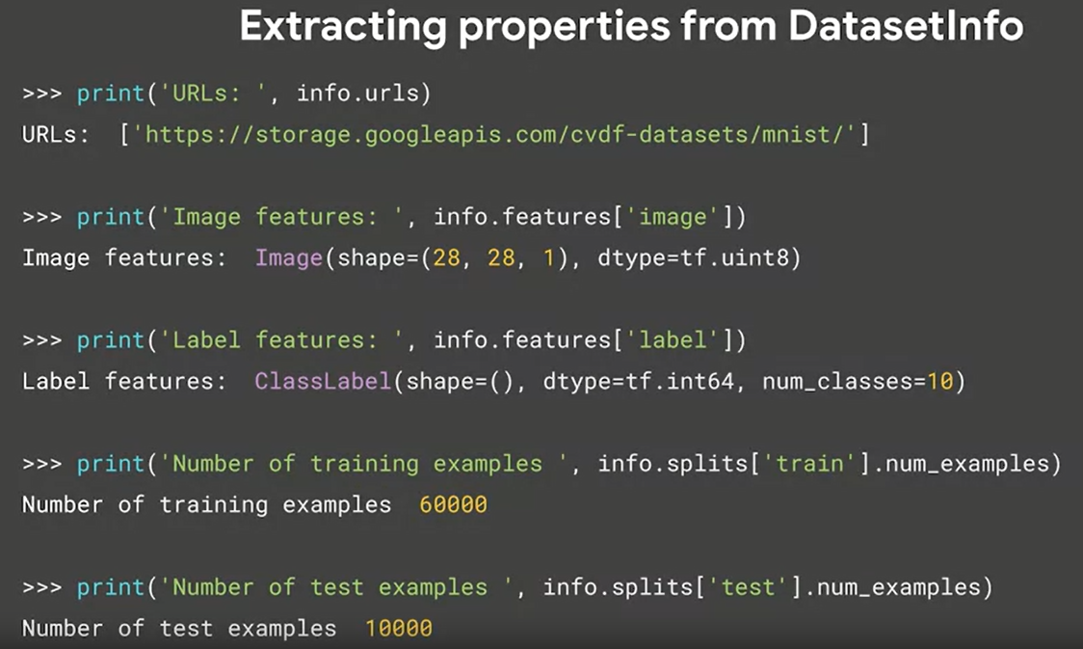

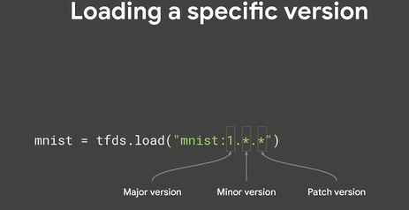

Incremented the major version, you may notice that the slicing API may not necessarily return the same set of records for a given slice. This can even be the case if the existing data has changed. An increase in the minor version signifies that there;s no change in the existing data, but it does imply that some additional featues have been added. Then lastly, in the event that the patch version has increased, the serializaion of disk may have changed.

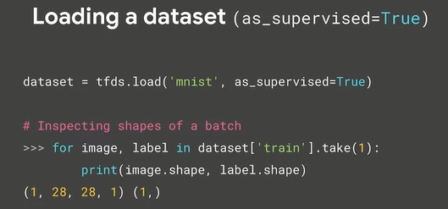

If as supervised is true, then your dataset will be performatted into tuples of data and label as you can see above, if you set as a false, your dataset will bbe available as a dictionary

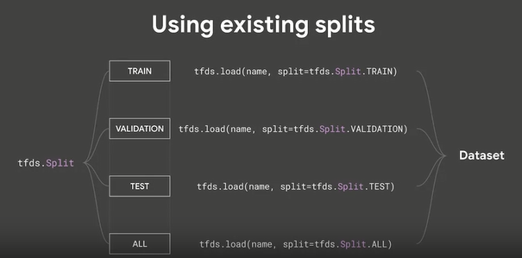

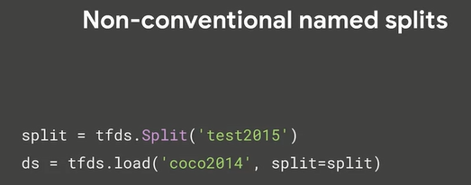

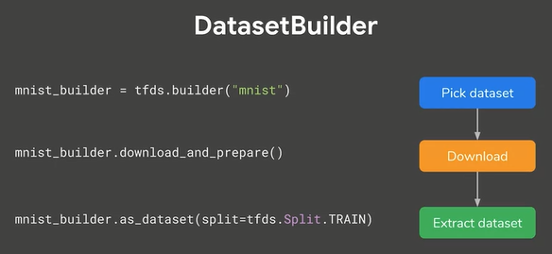

Using TFDS in Keras to train Fashion MNIST

From this

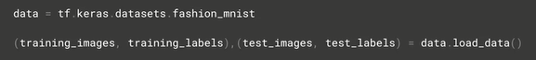

To this (instead tf.keras but tfds.load

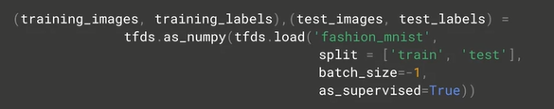

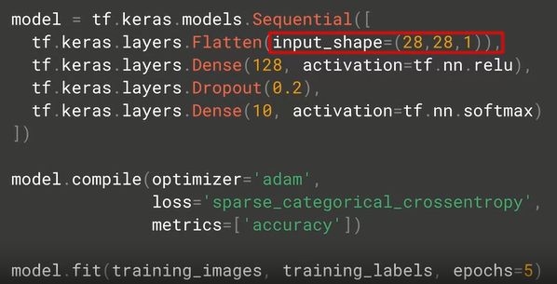

The horses or humans instead we need to extract zip etc, with tfds.load we can use:



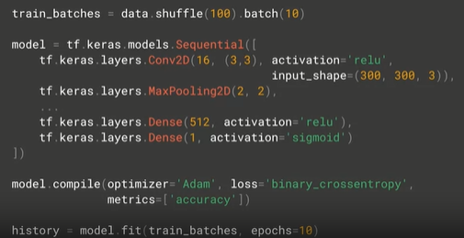

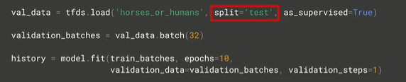

Week 2

The splits API and TFDS gives you fine grain control over how you split your data into training, testing, and validation sets.

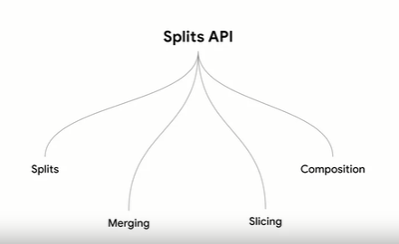

The python slicing API provides a simple string-based syntax that gives you great power over how you can slice and dice your lists and tuples.

<https://www.pythoncentral.io/how-to-slice-listsarrays-and-tuples-in-python/>

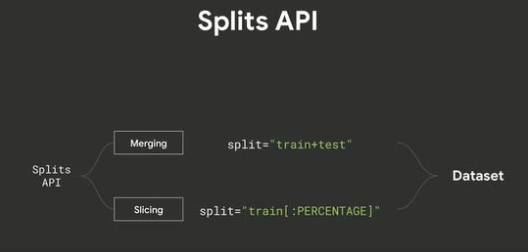

The core of this API is to use string literals to determine splits.

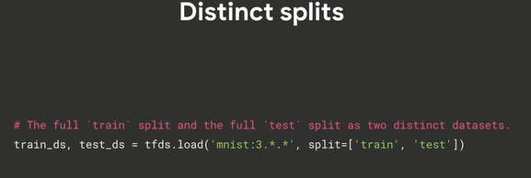

🡪 you pass a list of the splits that you need to tfds.load in it’s split parameter.

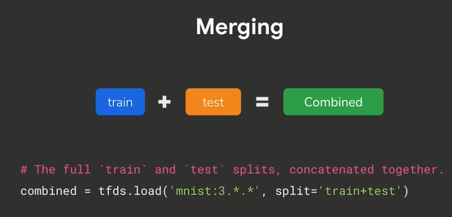

🡪 we can do merge with the plus operator passing the string containing the splits that you want to merge.

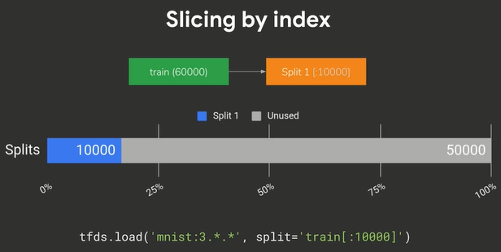

🡪 if you want to slice by index, again, you use the split parameter and specify the slice that you want with the familiar colon syntax from Python and that’s encoded in a string literal. For percent slicing we can also use this:



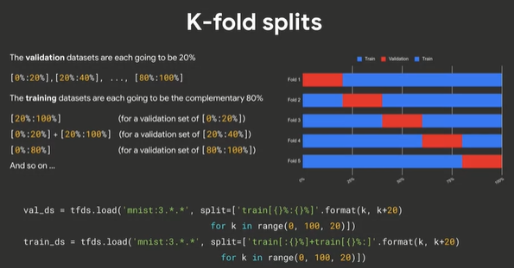

To see the real power of this, you can combine these for some sophisticated setups, such as k-fold splits, where you take the dataset and you split it into multiple folds, each of which has a different training and validation data location.

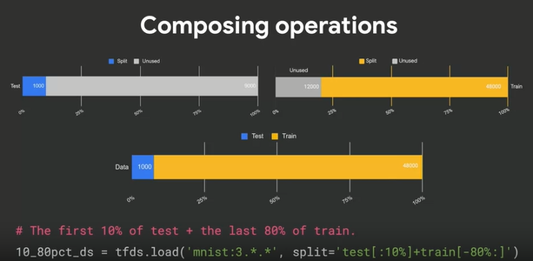

TF Records

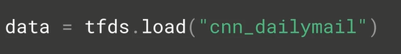

Output:

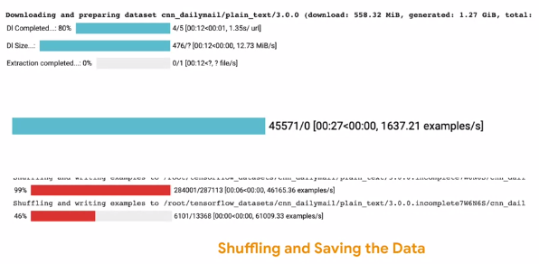

If we explore the file system it will be:

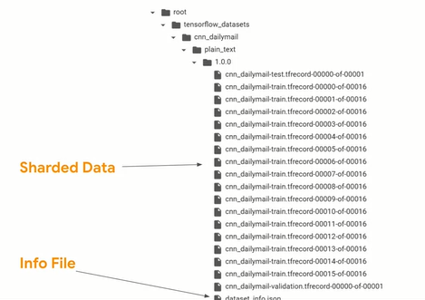

Info file will be there if we requestd the data set info using with_info = true

To make storage efficient, each of these shards is a cluster of records stored in binary format with a feature dictionary that gives us the key to decoding them. Ex:

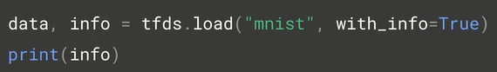

Output:

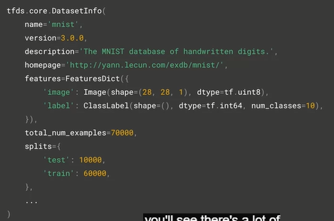

The things to zero in on is the description of the features which you’ll see in the features key, zoom:

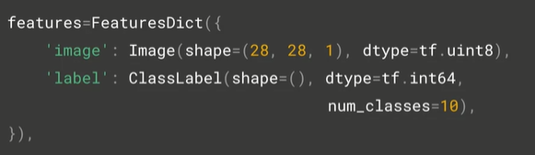

Image.image.json contains metadata about our pictures that’ll make them easier to decode. The content:



If we want to poke through the records to see what they look like, we can code:

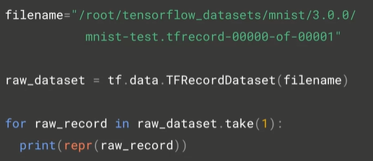

The repr will hel us formatting the binary data into hexadecimal representation when were printing it out. The result:

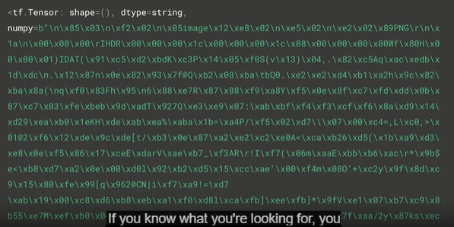

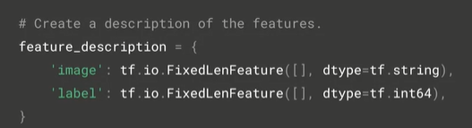

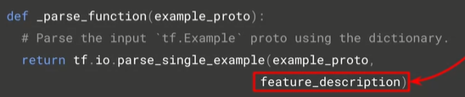

Tf.io.parse_single_example will break the data down into the image and label as defined in the feature description. To pase the data by specifying it as aour mapping function that gets called as the data is read we can use this code:

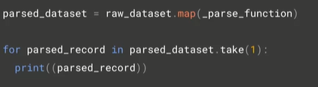

Result:

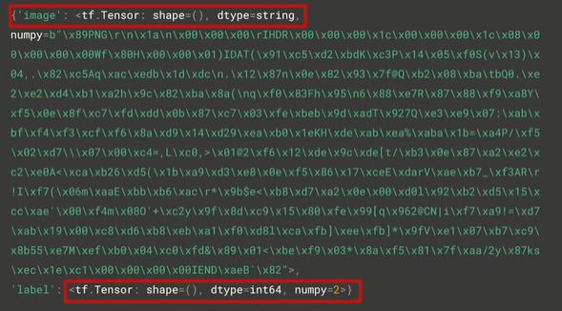

Week 3

Will learn about tools that will make it much easier for you to work with data from a variety of sources. This week, you’re going to start looking at the code for using the data with input pipelines.

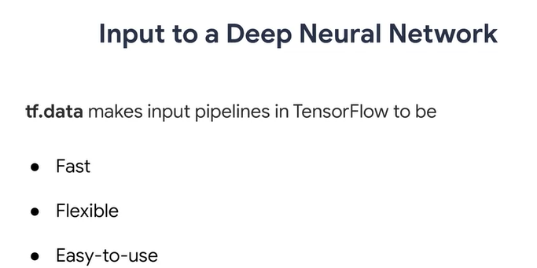

NN expect numbers as inputs. Real-life input data may contain non-numerical data such as strings, numbers that represent categories. We can create input pipelines to process these inputs into the form that can be used by the NN. The tf.data API enables you to build complex input pipelines from simple reusable pieces

Example image model pipeline

* Aggregate data from files in a distributed file system
* Apply random perturbations to each image
* Merge randomly selected images into a batch for training

Example text model pipeline

* Extracting symbols from raw text data
* Converting them to embedding identifiers with a lookup table
* Batching together sequences of different lengths

The tf.data API helps to build flexible and efficient input pipelines, it also makes it possible to handle large amounts of data, different data formats, and of course perform complex transformations. The bottom line is, tf.data can be fast, flexible, and sometimes quite simple to use.

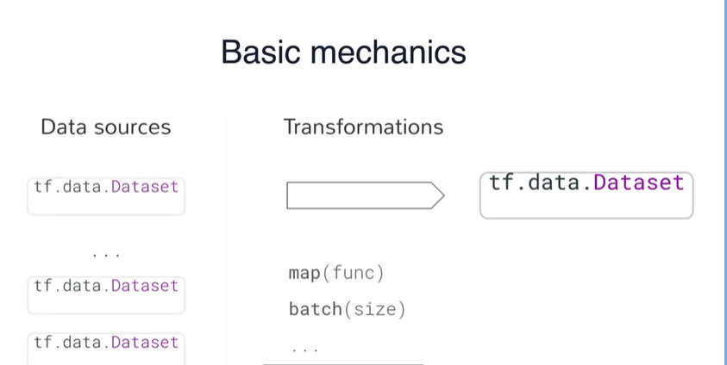

To create an input pipeline, you must start with a data source, and tfds represents this as datasets. So one you have a dataset object, you can transform it into a new dataset by chaining method calls like the ones that you can see above. So for example, you could use the map function to apply per element transformation and the batch operation, which lets you do these transformations on multiple elements at once. Example:

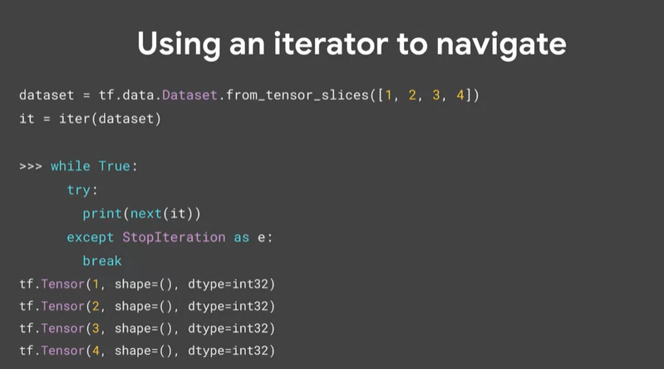

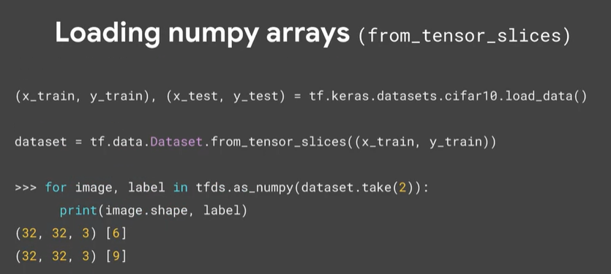

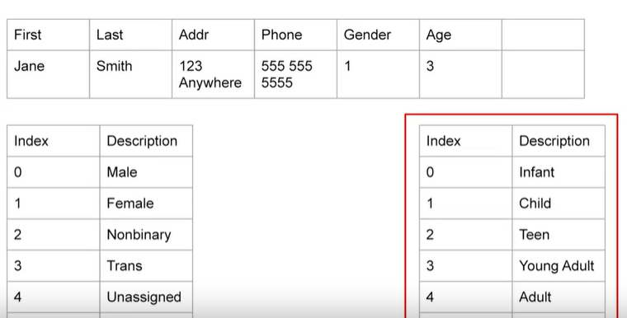

There are both are example of feature columns  
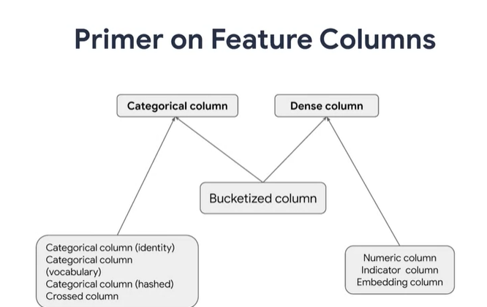

Here are all the different types of feature columns available in TensorFlow which can be used by tf.data seamlessly with no issues whatsoever. At a higher level, you see that there are categorical columns and dense columns for numeric and embedded features. However, there is an exception with the bucketized-column inheriting from both categorical and dense columns.

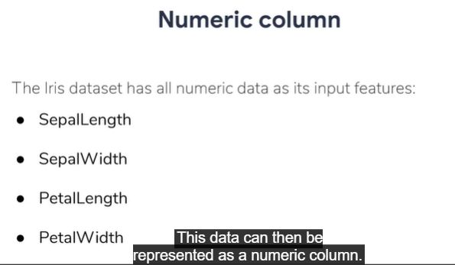

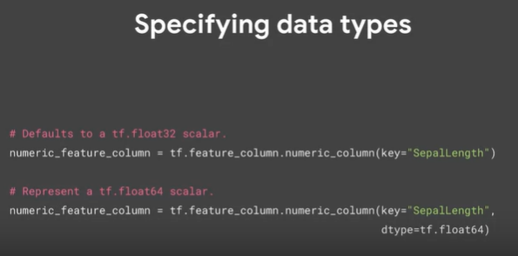

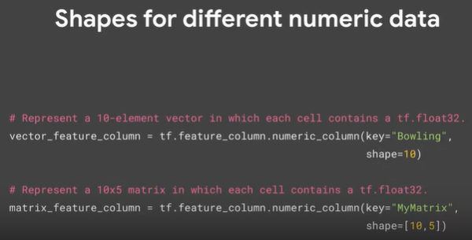

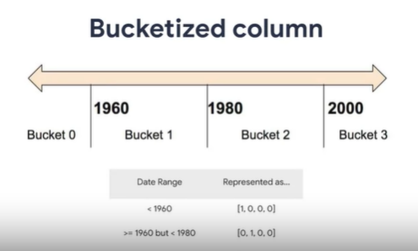

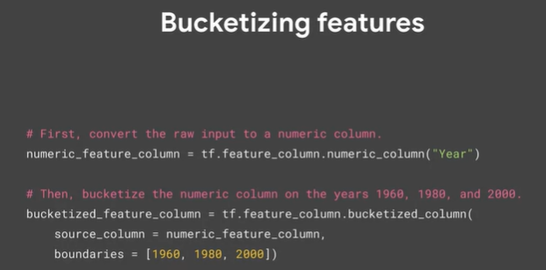

A special case of bucketize columns can be seen with categorical identity columns, where instead of ranges, we can have straight values that are one-hot encoded.

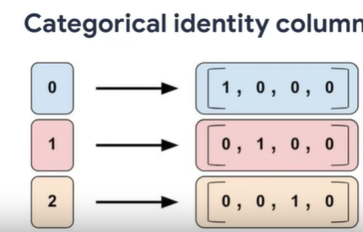

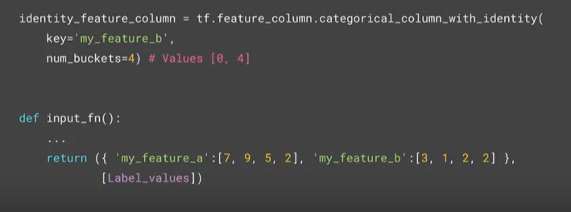

Here is the example code that calls tf.feature_column.categorical_column_with_identity to implement a categorical identity column. Create categorical output for an integer feature named "my_feature_b". The values of my_feature_b must be greater than or equal to zero and less than the number of buckets. For the preceding call to work, the input_fn() must return a dictionary containing 'my_feature_b' as a key. The values assigned to 'my_feature_b' must belong to the set of numbers from 0 to 4, excluding 4.

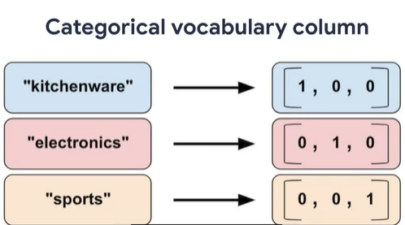

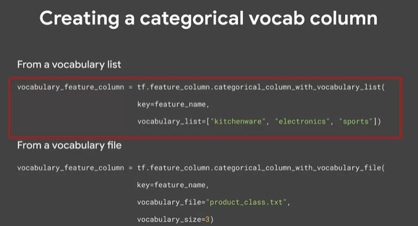

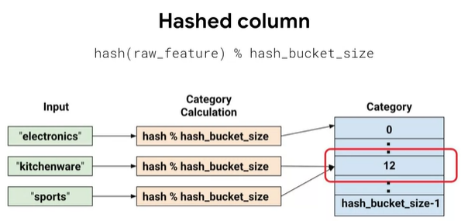

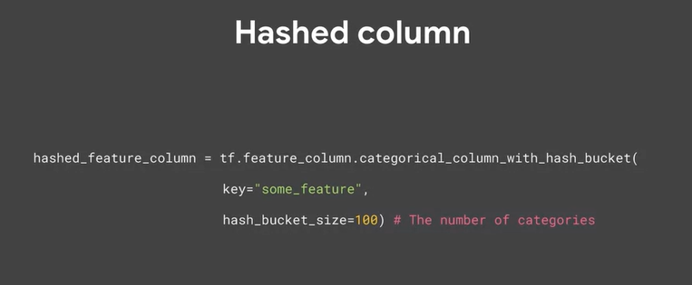

Combining features into a single feature, also known as feature crosses, enables a model to learn separate weights for each combination of features.

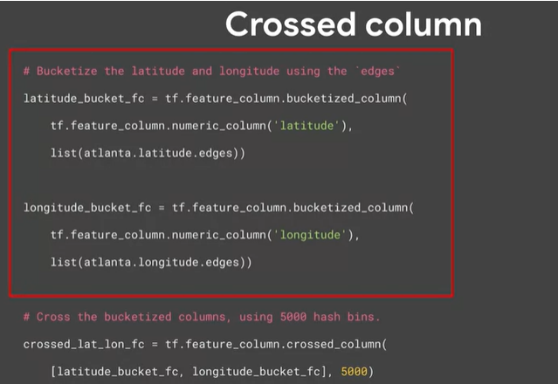

Feature crosses are synthetic featured formed by multiplying (or crossing) two or more features. Crossing features can provide predictive abilities beyond what those features could provide individually.

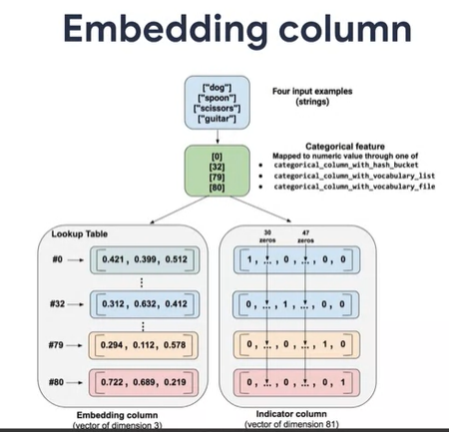

One downside with one hot encoded vectors that you’ve seen so far is that they can lead to some very large sparse and inefficient vectors embedding columns work very well to avoid this

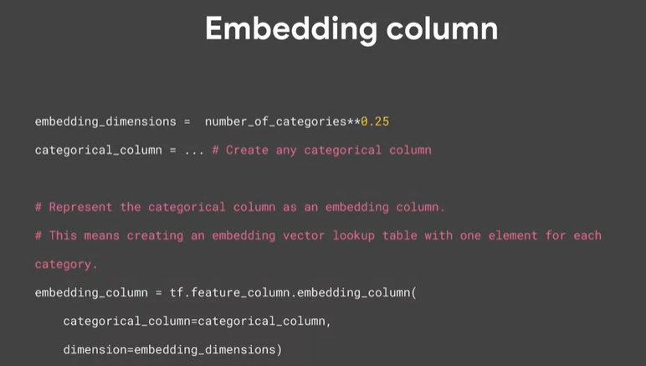

Let’s see how data gets loaded and extracted to the ETL pipeline. There;s lots of ways data can get into the pipeline, and we’ll explore some of the most commonly used including Numpy, DataFrames, Images, CSV and text, TF records and generators.

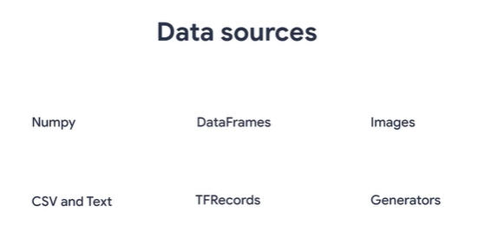

Numpy

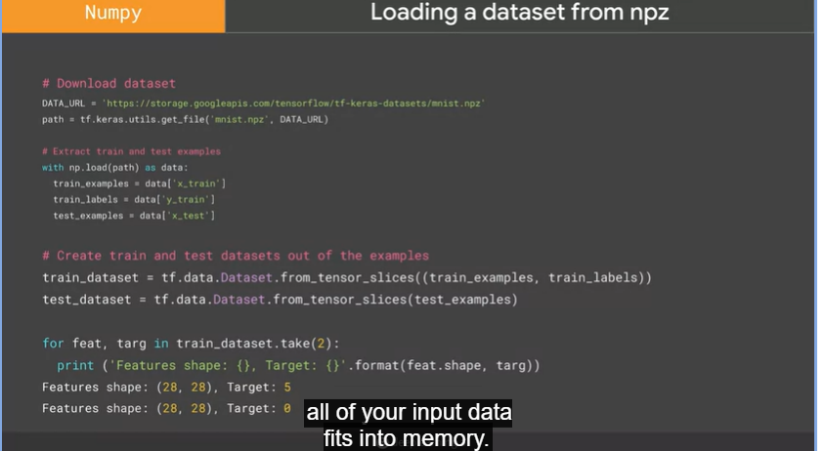

You’re most likely to use a numpy array if all of your input dat fits unto memory. The simplest way to read a Numpy array, is by emplyinh the tf.data.dataset from Tensor slices function.

Pandas

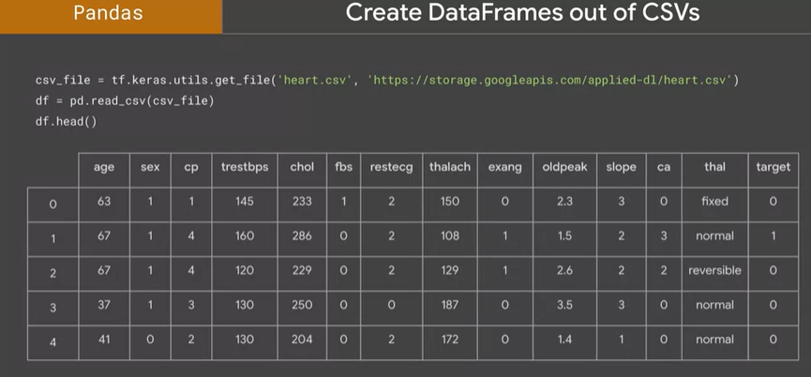

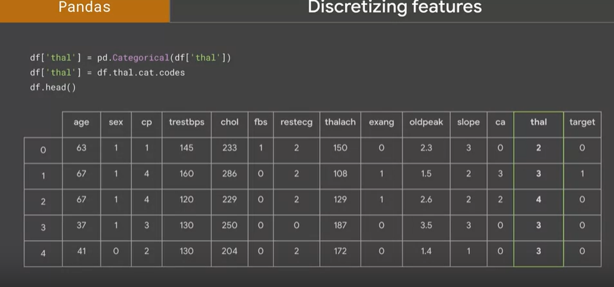

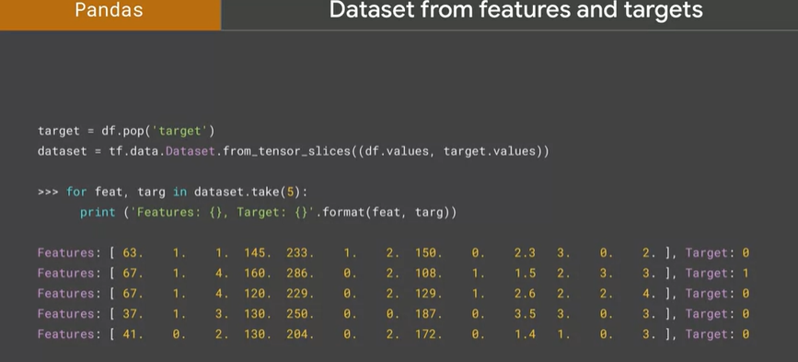

Images

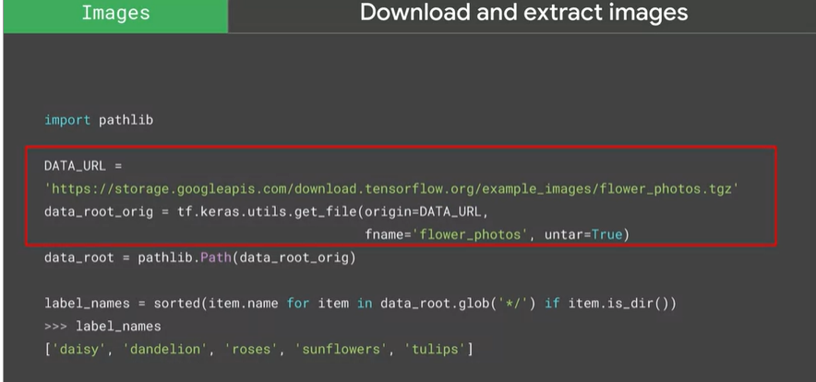

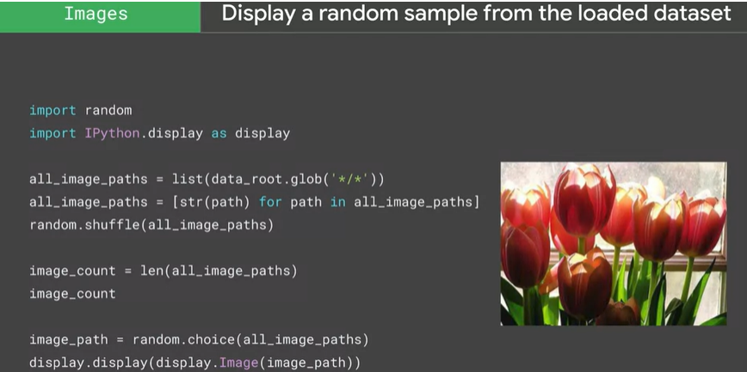

CSV

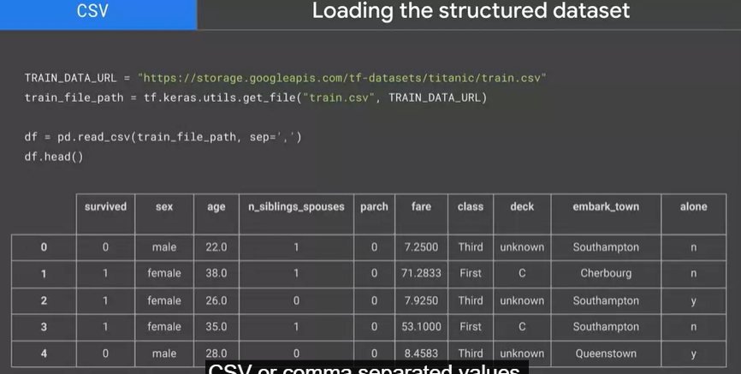

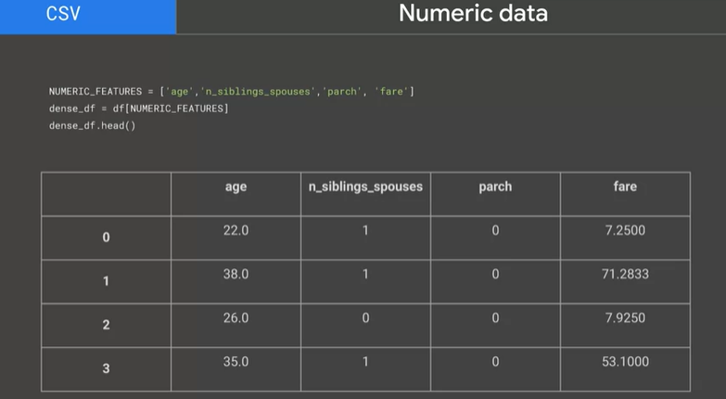

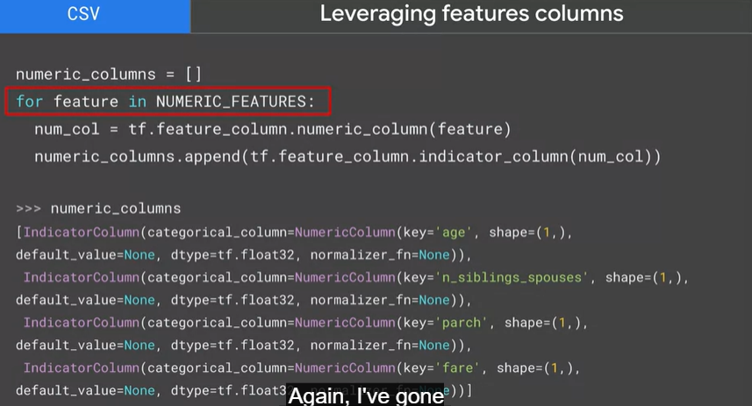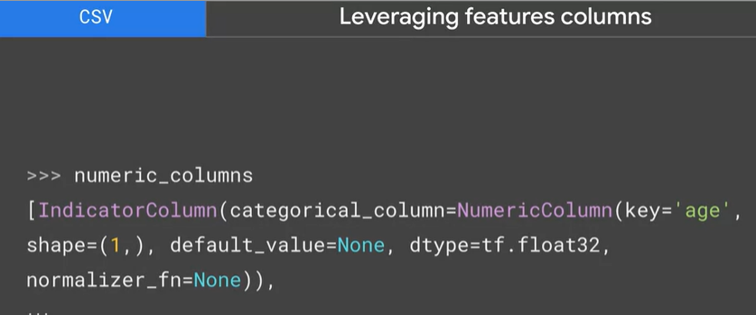

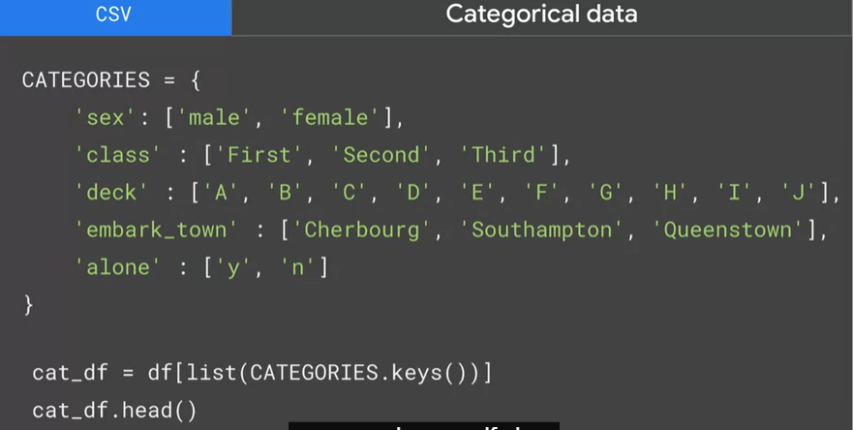

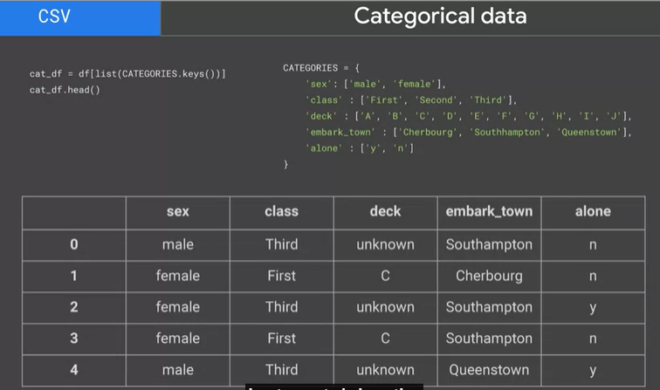

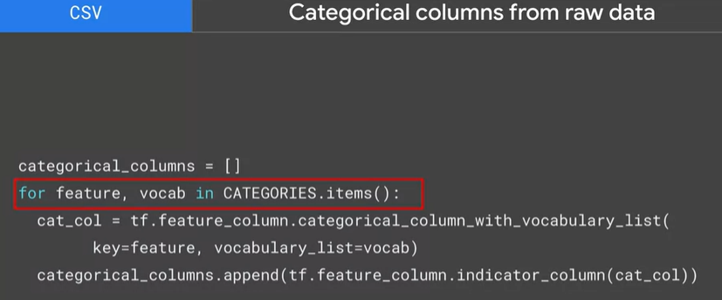

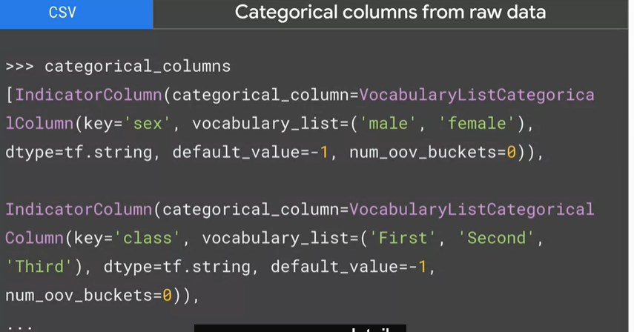

Text

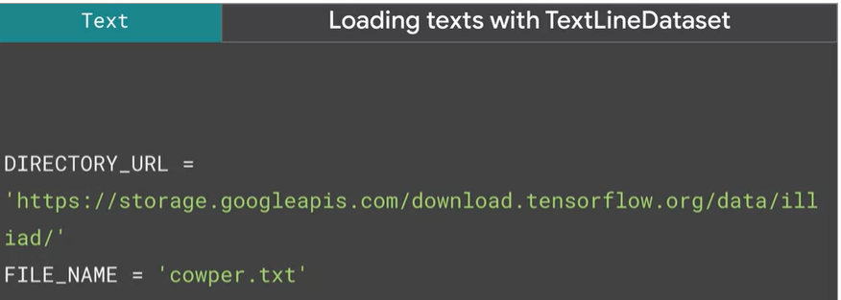

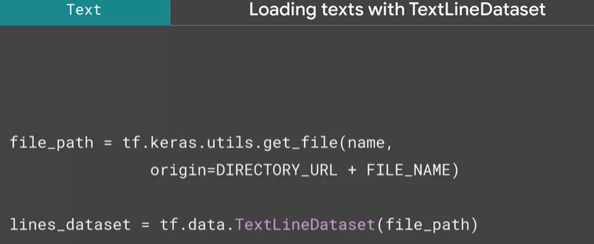

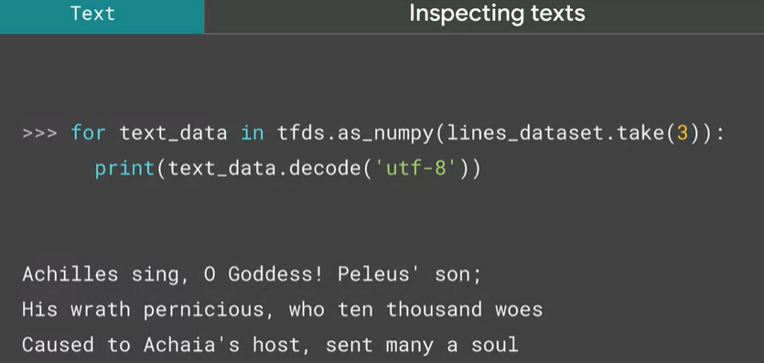

TFRecord

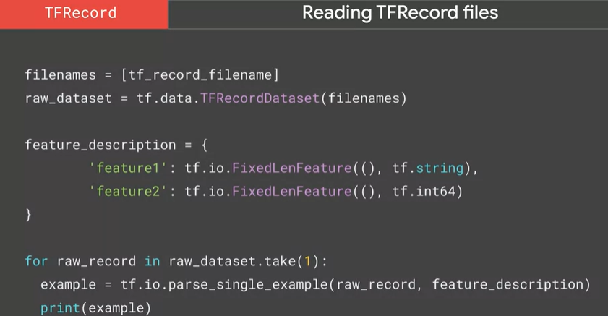

Generators

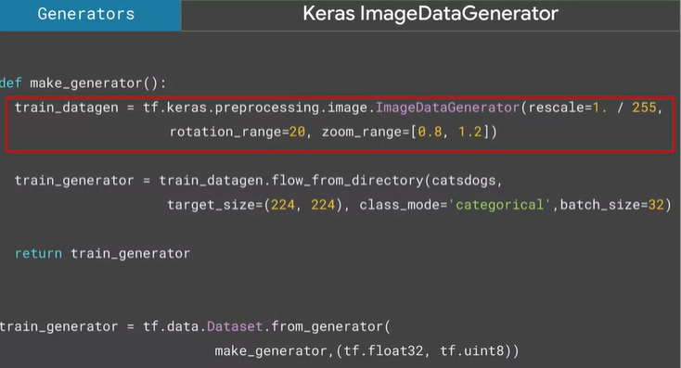

How to load data into TF using TensorFLow and tfds tools, how to load from their native format?

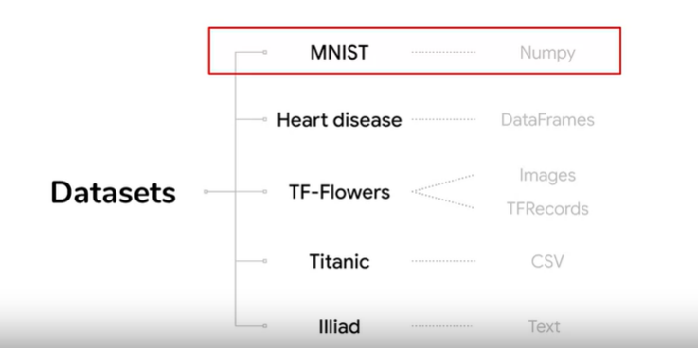

Numpy (MNIST )

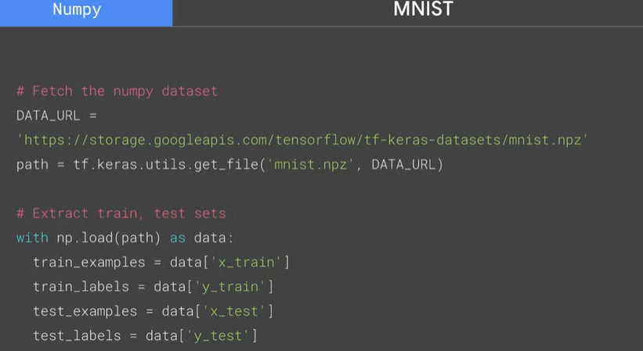

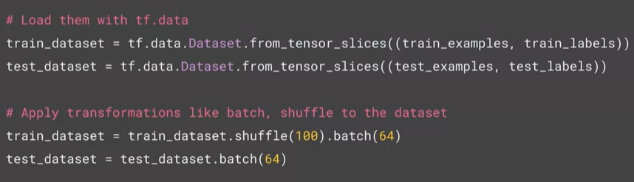

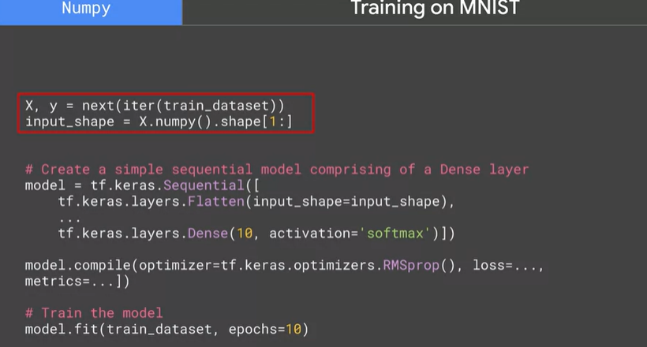

Pandas (Heart disease)

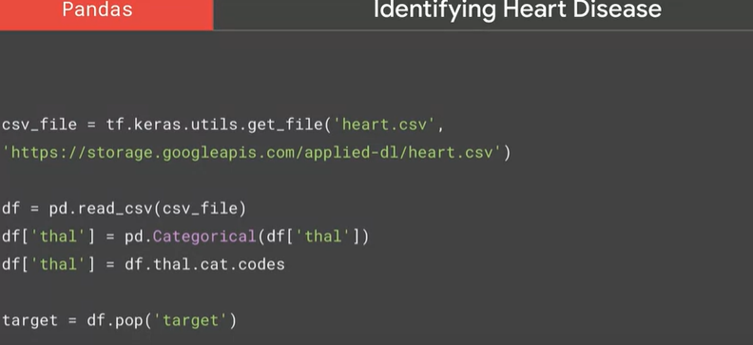

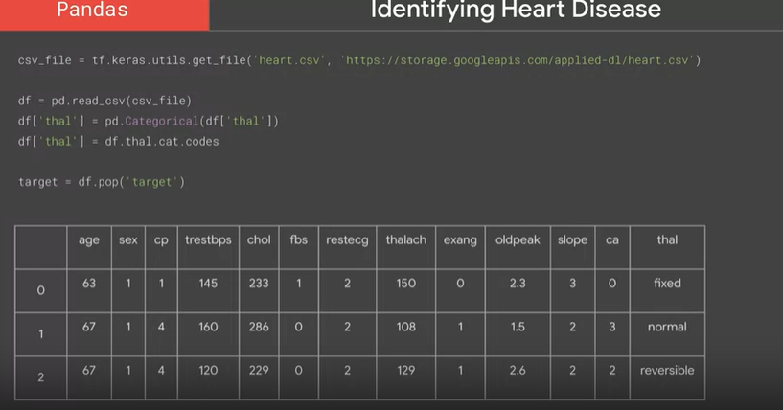

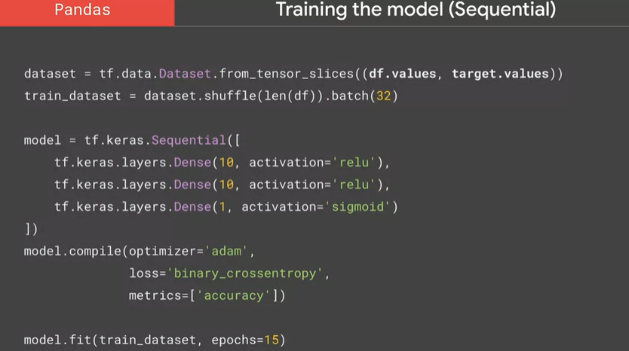

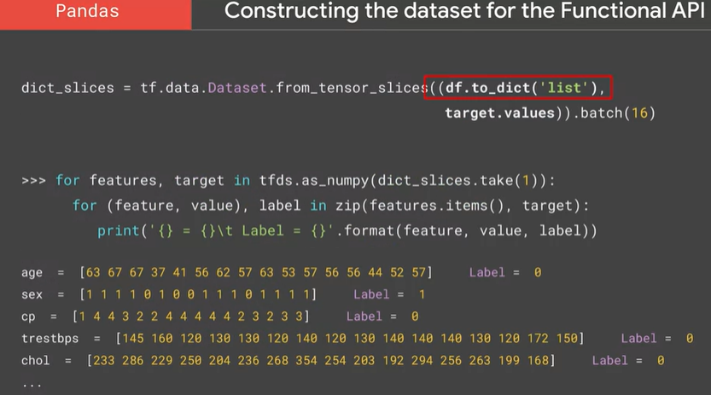

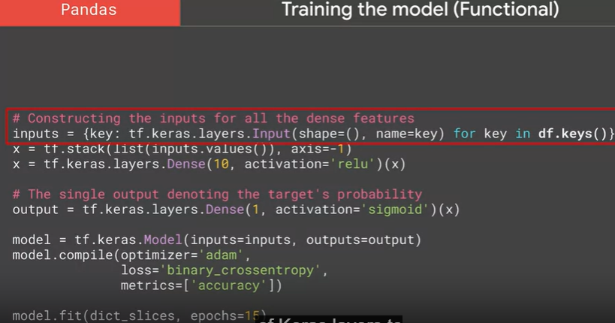

Images (flowers)

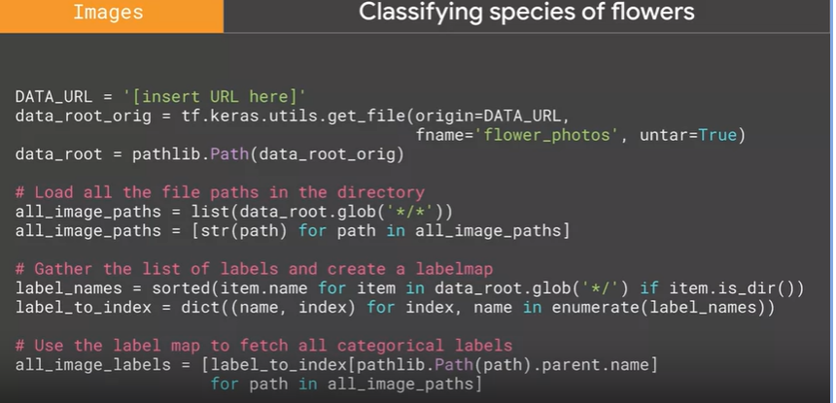

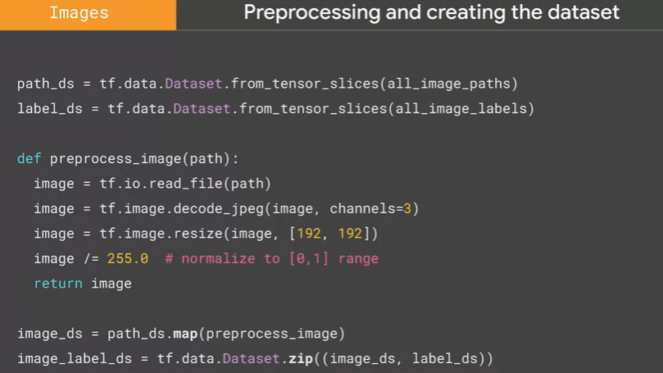

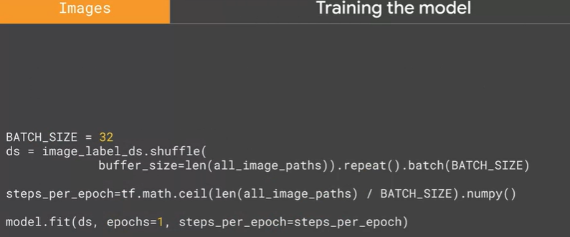

CSV (titanic)

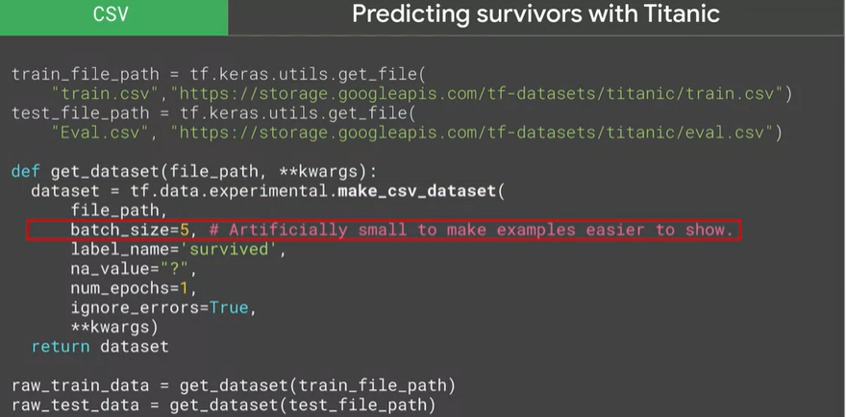

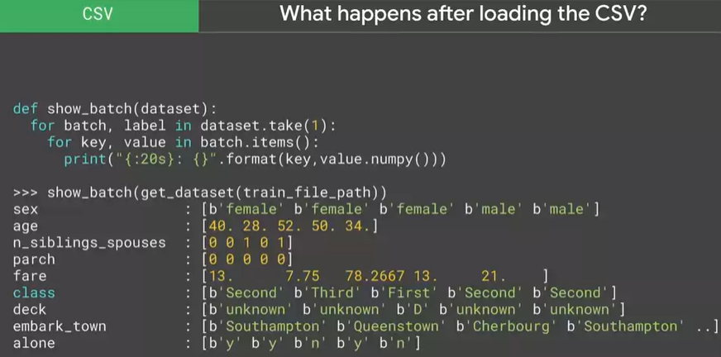

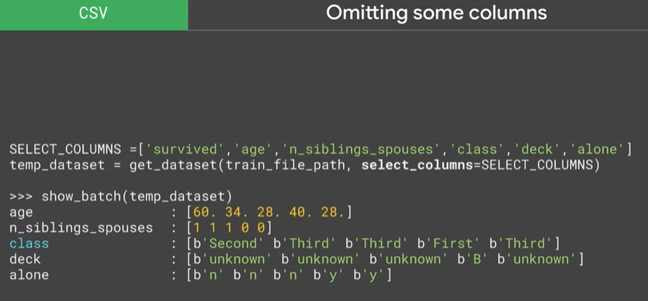

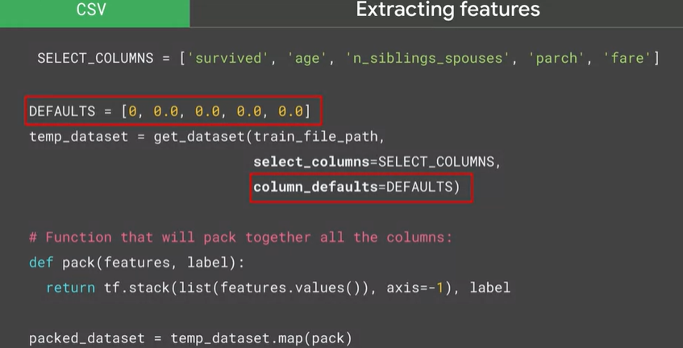

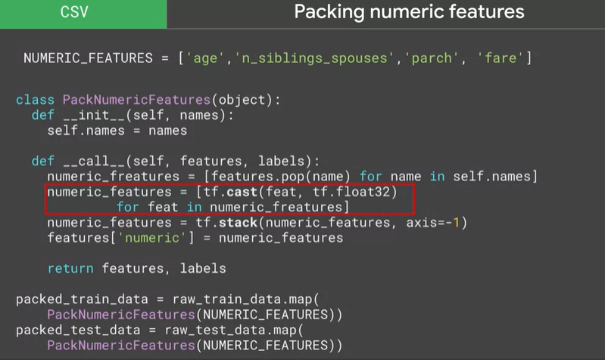

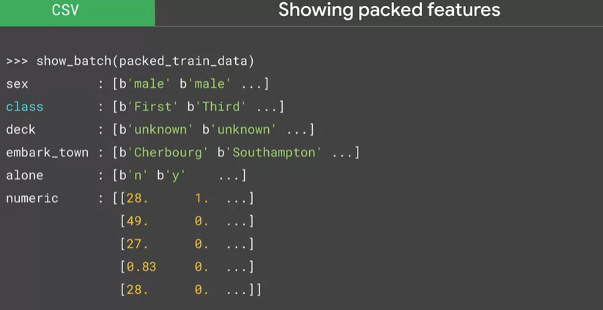

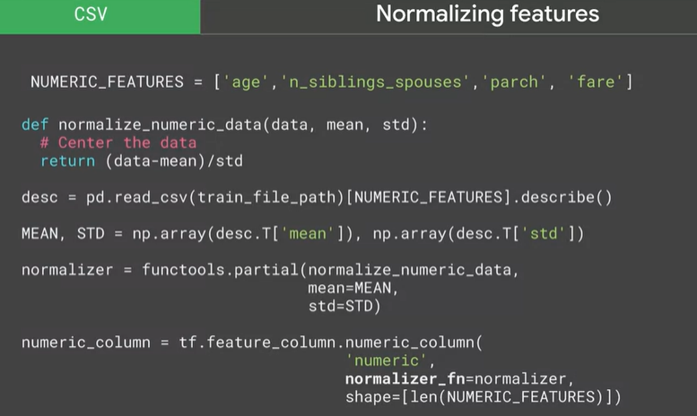

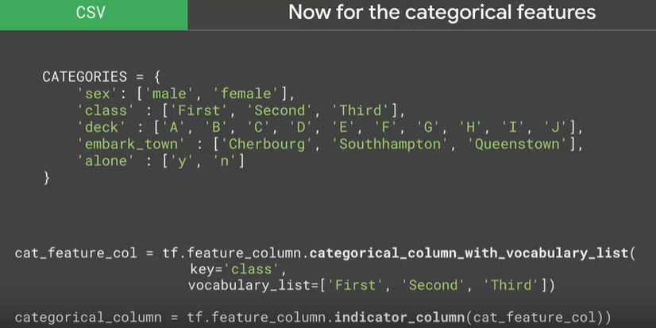

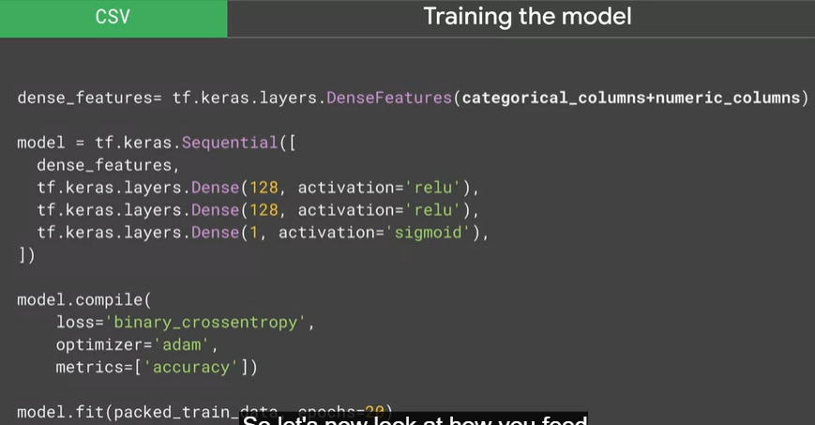

Text (Iliate)

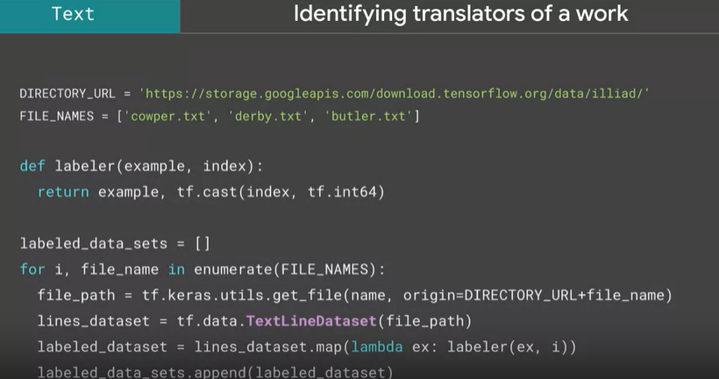

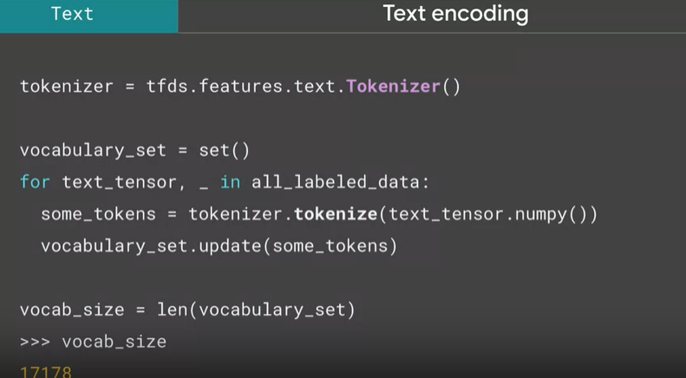

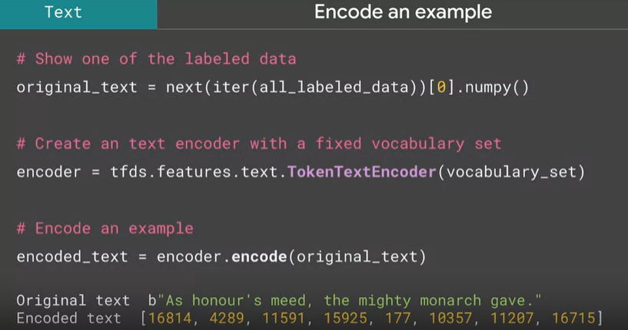

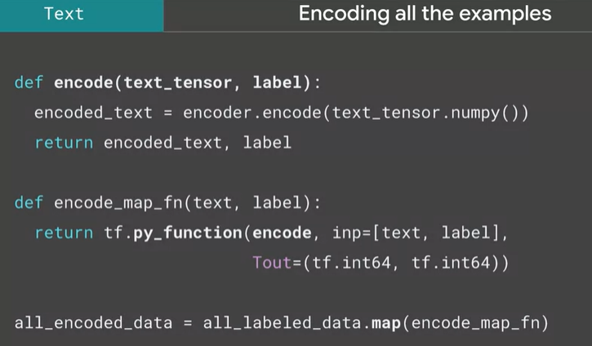

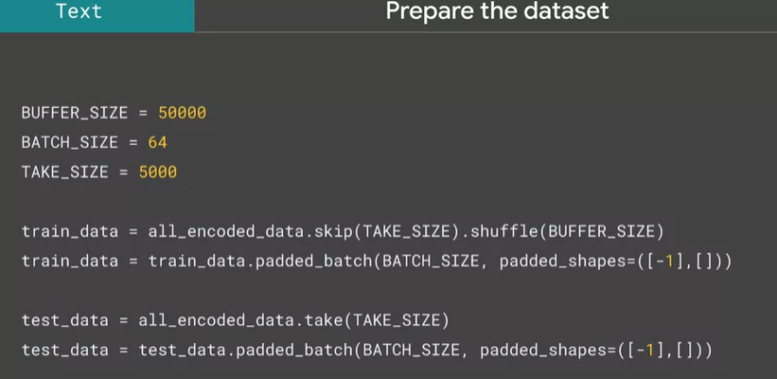

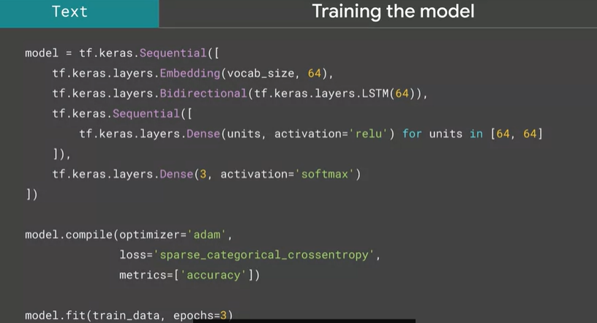

Week 4

Learn how to build efficient data pipelines using TF ETL APIs. Make both GPU and CPU work efficiently at the same time.

GPU 🡪 training model

CPU 🡪 keep GPU well fed with data.

In this week we’re going to look how to load your data into your model can have a huge impact on how efficiently the model trains.

Typically we thought that bigger, faster number-crunchers, better CPUs, GPUs, or Tpus are the key to faster training. They can be but they can also be very inefficiently used if youdont have a good data pipeline

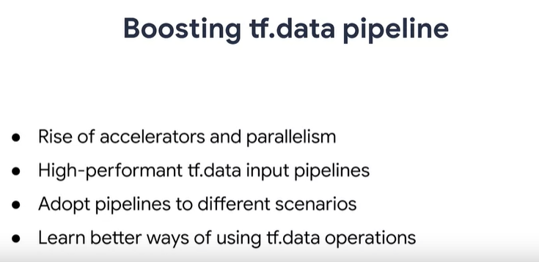

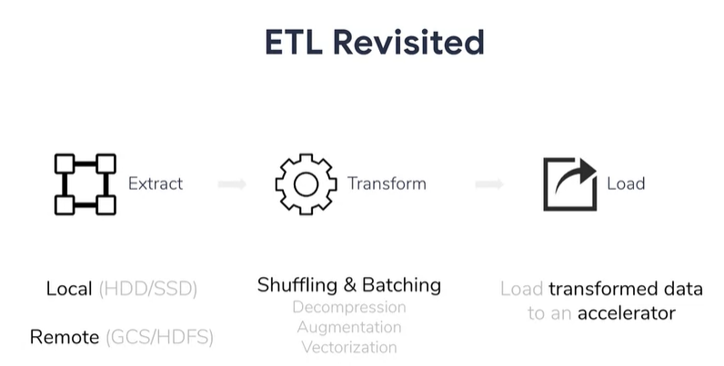

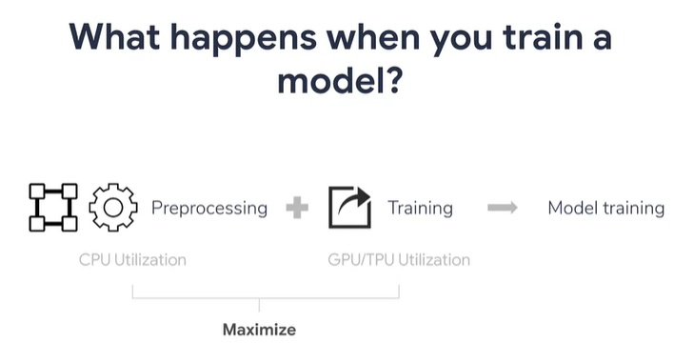

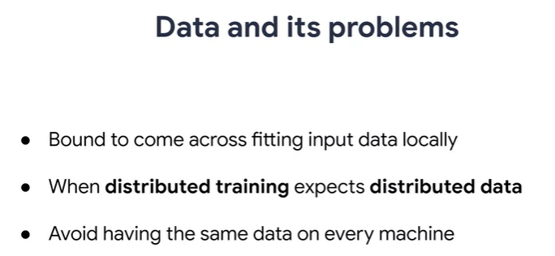

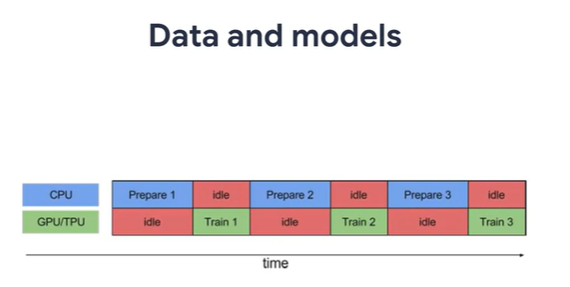

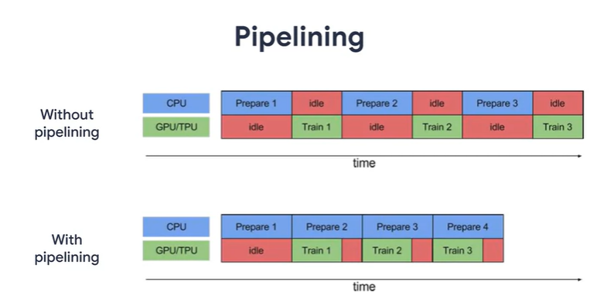

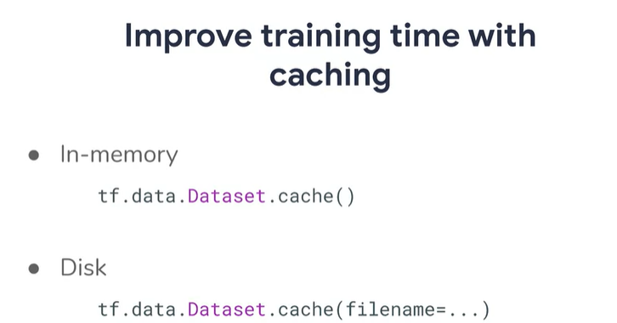

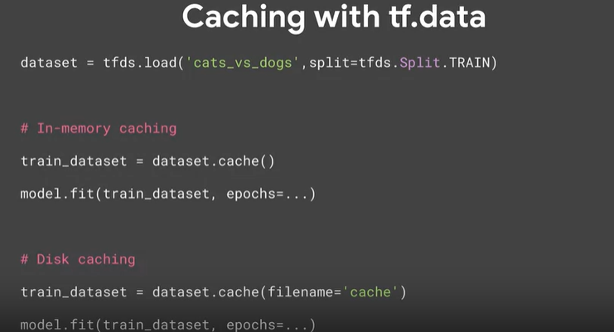

A handy tool for performance is caching. The tf.data.Dataset.cache transformation can cache dataset either in memory or on local storage. If your data can fit into memory, use the cache transformation to cache it in memory during the first epoch. This is done so that subsequent epochs can avoid the overhead associated with reading, parsing and transforming it.

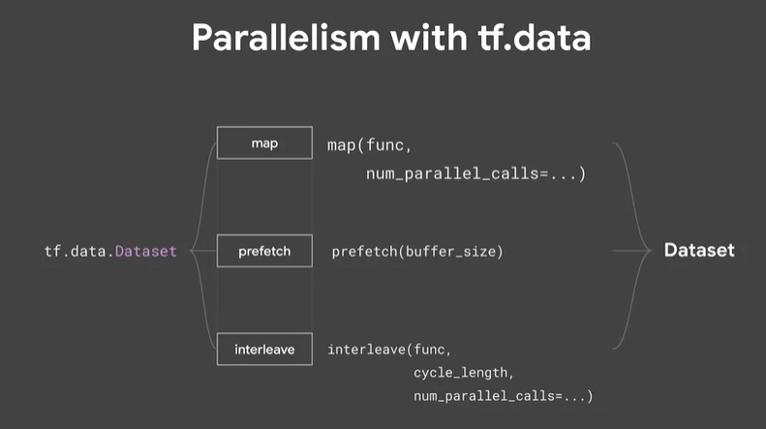

We know that

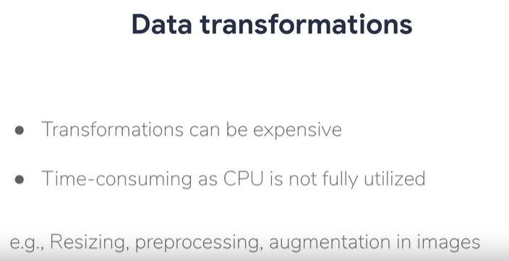

Ex for trans:

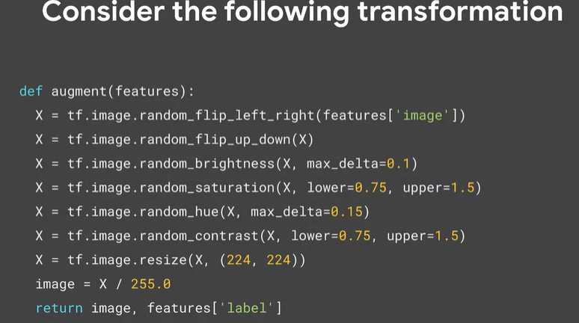

Rather than those thing above we can use this:

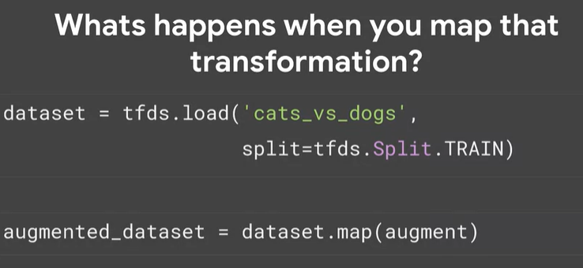

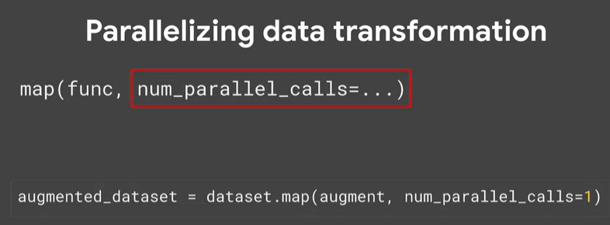

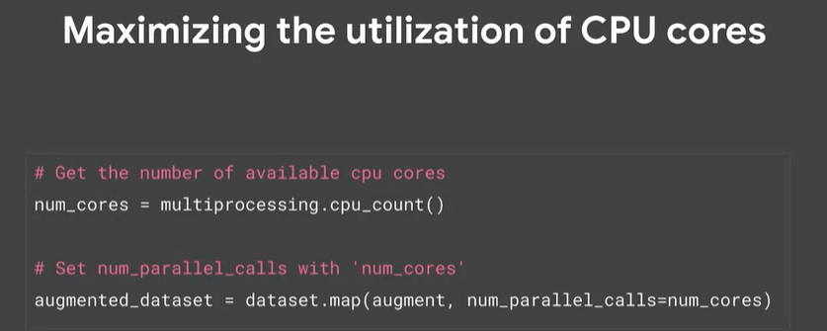

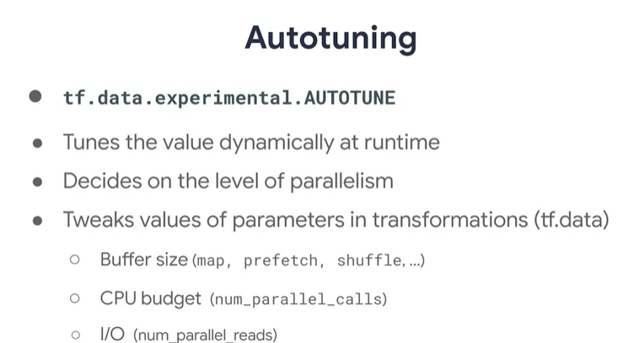

Auto-tune delegates the decision about what level of parallelism to use for the tf.data runtime. Under the hood, it identifies the algorithm to use for performing the autotune optimization.

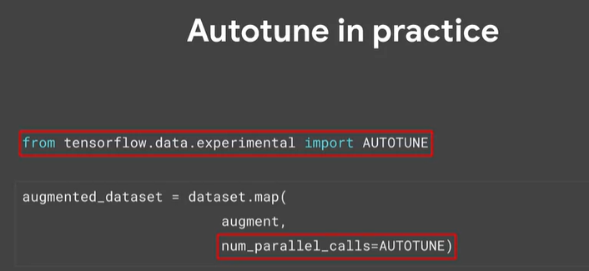

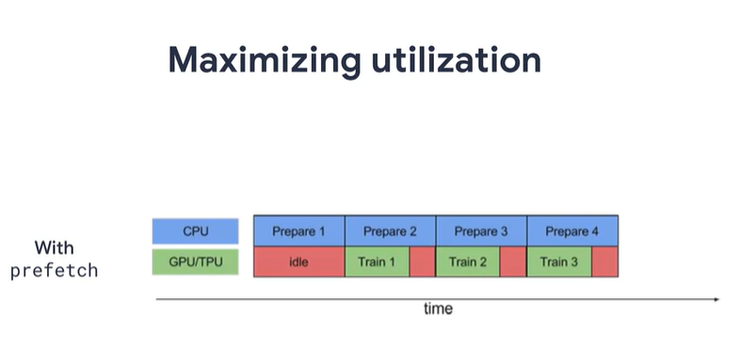

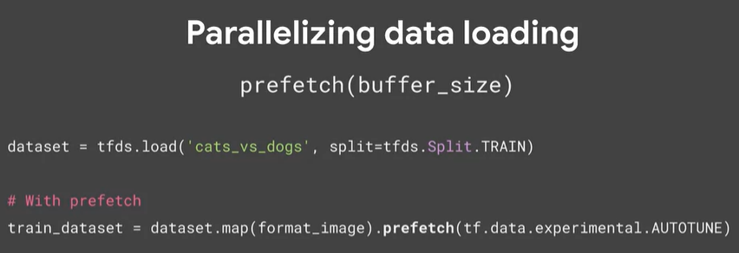

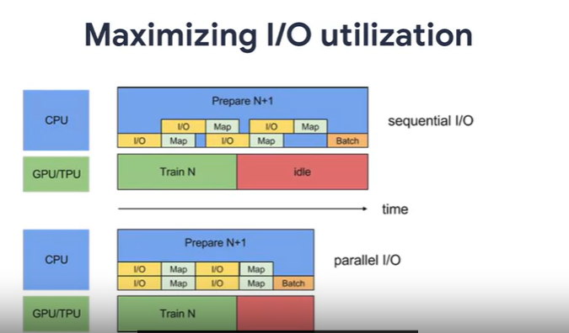

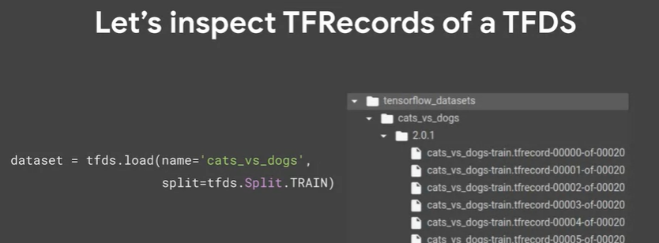

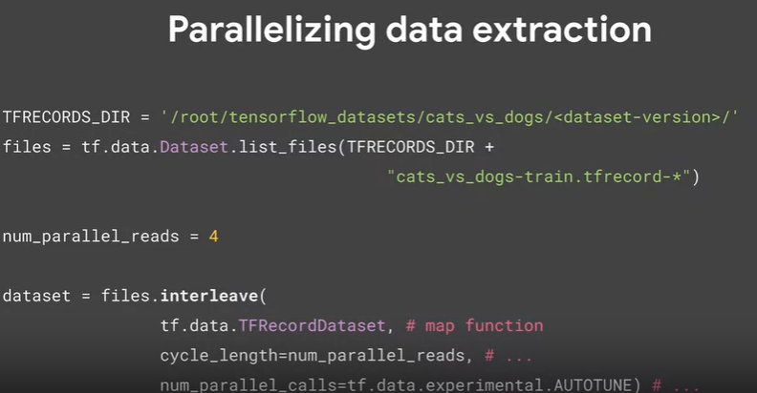

Best Practice

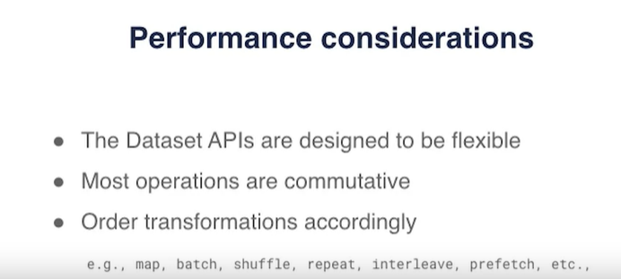

One of the biggest negative impacts. If you aren’t careful with your coding is in the ordering of the functions we’ve been looking at first of all is the map transformation and this can have significant.

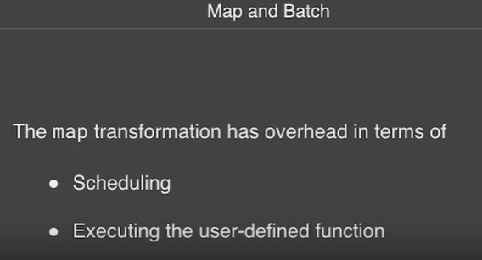

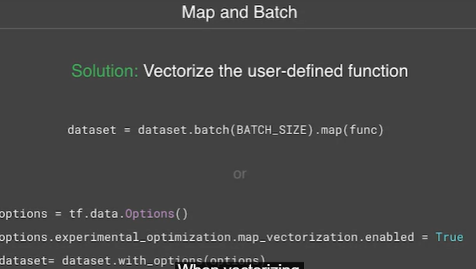

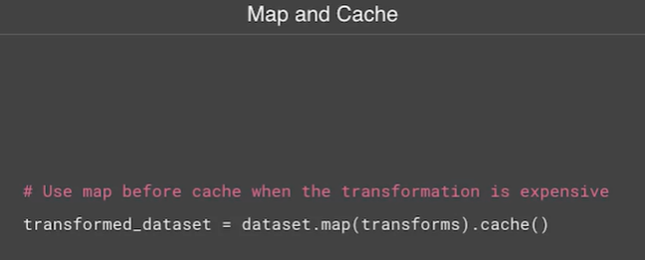

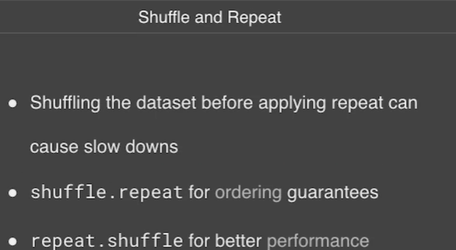

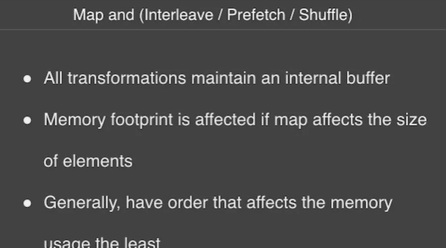

URL for publishing your dataset

Please find below the following URLs:

1. [Creating a file](https://www.tensorflow.org/datasets/add_dataset)

2. [Creating a custom bibtex entry](https://truben.no/latex/bibtex/)